Some MUST READ tips before you do the firmware & software upgrade

Please check your GD-77 firmware version before upgrade:
V2.6.6, V2.6.8, V3.0.6----upgrade directly to V3.1.1
V2.6.2, V2.4.2 or others----upgrade firstly to V2.6.6, V2.6.8, V3.0.6 then to V3.1.1
Otherwise it might cause Abnormal power after reset on the GD-77.

1. Software V3.1.1 MUST WORK WITH firmware V3.1.1
2. After successfully upgraded, the CSV file from old version V1.X.X and V3.0.X will NOT be compatible with the completely new version V3.1.X. You will have to use the new CPS to import a new template to do the bulk operation;
3. Please do follow the rules that mentioned above, and if you failed to upgrade your radio please all and try again.

PS:
1：After update the radio firmware successfully, please install the latest software. Below steps are MUST READ part:

Example：
If you need to upgrade from V2.6.6 to V3.1.1, please follow these steps:
a. click the new software V3.1.1
b. connect radio to computer
c. build the new dat file
d. after building the new dat file, please write in the radio directly (Please DO NOT "read", or it will lead to unkown error. Reason: The part data storage location has changed.)
e. Press [SK2] + number [9] to reboot. Then shut down
f. Please use the new software template for batch import
g. After doing all above operations, you could use or program the radio as your own requirement. Please just use the new software and delete all the old dat files and templates.

Operation will overwrite your old data, please save in advance.

What’s NEW with this software V3.1.1 & firmware

1. ADD VFO
How to enter VFO mode: short press the right arrow key on the keypad → to switch the VFO and MR; short press the left arrow key ← to switch the frequency bands.
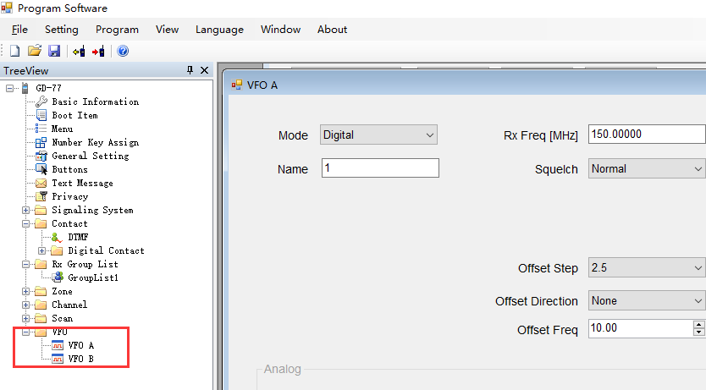

2. Contact ID
The number of digital contact IDs has been expanded from 256 to 1000.
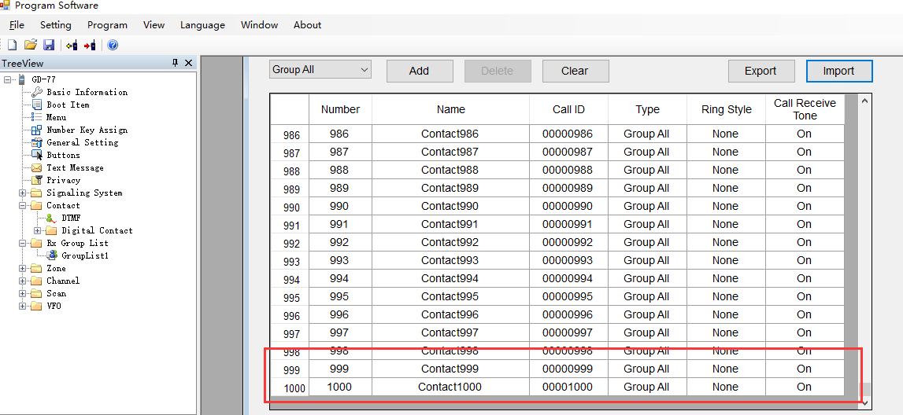
3. Scan list & Channel list

The number of scan list is expanded from 16 to 64, and the number of channel list is expanded from 16 to 31.

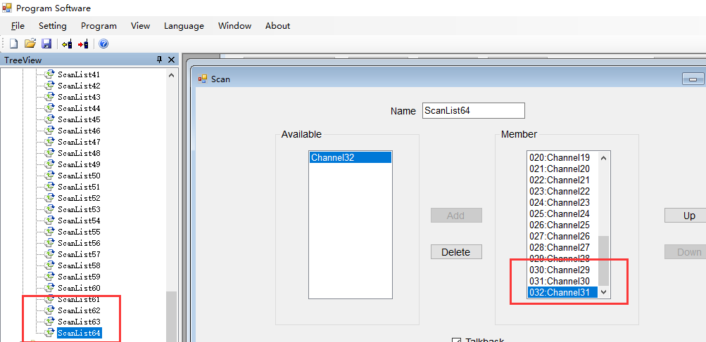

4. DMR ID Database

We provide a total of 49607 people with DMR IDs registered globally, under the file name “datadump”. As GD-77 can only support saving the top 10000 from the list as default, please select the IDs you want to add.
For more details of the import operation, see: DMR ID operation.

Note:
1：Read and write DMR ID data: Press SK2+Menu+# key at the same time to turn on radio
2：Please DO NOT delete or modify the first row
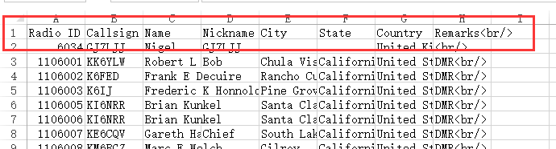

5. Fix the bug of zones lost

6. Fix the bug of distorted audio

