Firmware V3.2.1
1. Lock frequency range to meet FCC rules
2. Solved GD-77 (INVERTED DISPLAY VERSION) screen flashing when turned on
Note: Two ways to unlock frequency range
I. Press “SK1” + “7” key to turn on the radio - Press “Menu” to restart
II. Downgrade to old firmware version

Firmware V3.1.8
1: Solve DTMF decoding issue--the other channel number cannot be decoded after the DTMF in Double Standby (Double Single)
2: Add ANI display

Firmware V3.1.3
1：Solved Some Radio Call ID is not Displayed Properly

Software V3.1.1
Firmware V3.1.1
1：RX Group List - Contact 16 →Contact 32
2：RX Group List 128→ 76
3：ADD Scan Time Setting
4：VFO Bug Repair

V3.0.5
1：ADD VFO
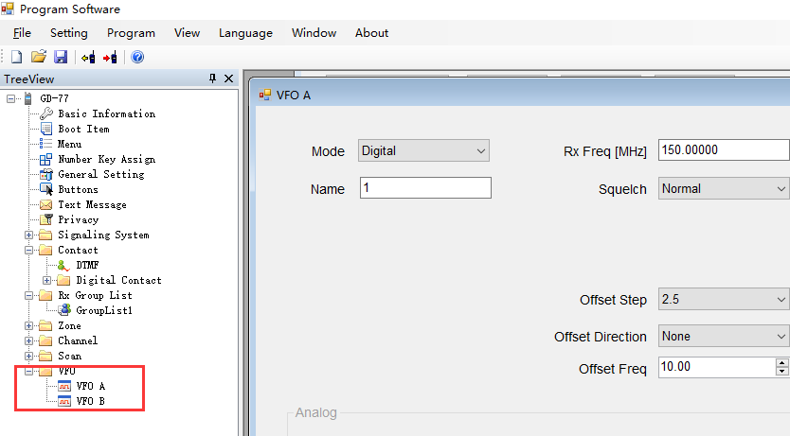
2：Contact ID 1000
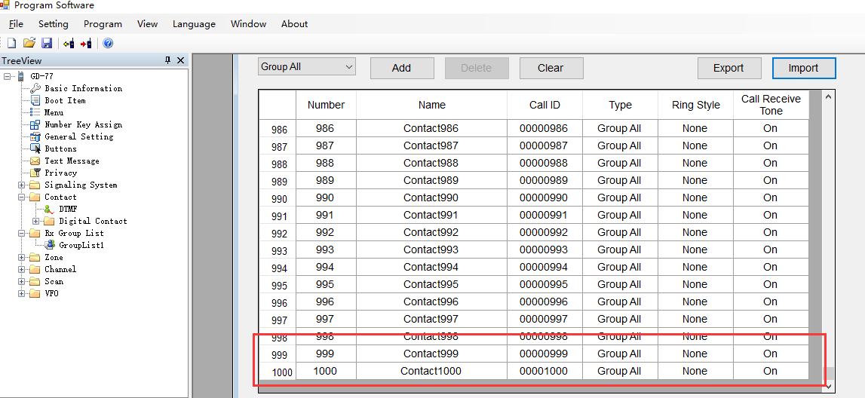
3: Scan list 64
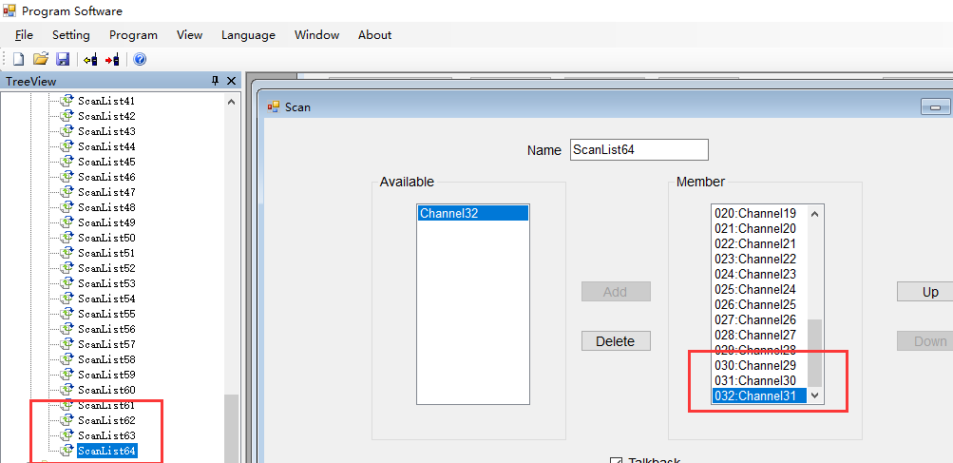
ADD DMR ID
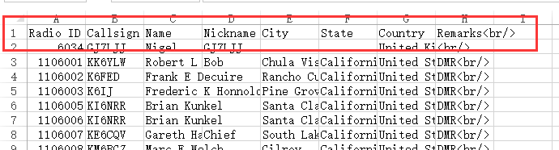

4：128 RX Group List
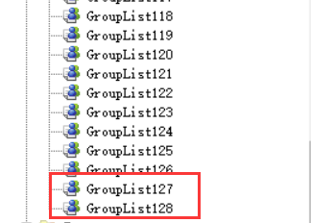

5：ZONE Abnormal Repair

6：2.5K step
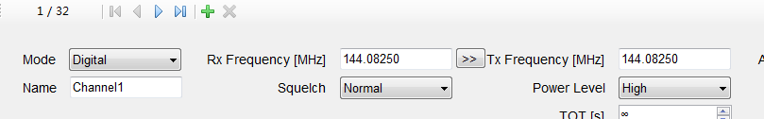
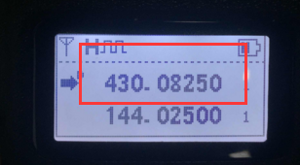

7:Europe Input Method CTCSS/DCS Save:
